Thank you to all patients that participated in the recent survey organised by our Patient Participation Group (PPG). The data generated from a total of 1008 responses is summarised below. A free text comment section was available for users to leave comments and suggestions, and this feedback has been collated with responses, where possible.

Results

Question 1: Please confirm the last time you used the GP practice, excluding the pharmacy. If you are not sure, an approximate answer will suffice.
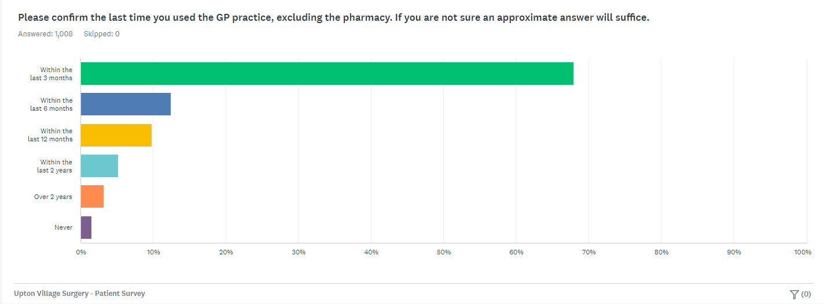

Question 2: If you have used the practice, excluding the pharmacy, within the last twelve months, please indicate how many times you have used the services. An approximate answer will suffice.

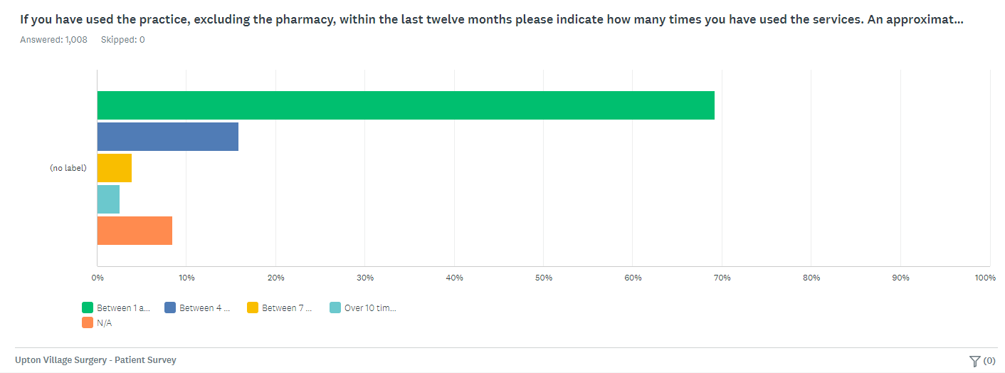
Question 3: If you have used the services of the practice, excluding the pharmacy, within the last 12 months, how would you rate the overall service? If you have not used practice services within the last 12 months, please answer n/a.

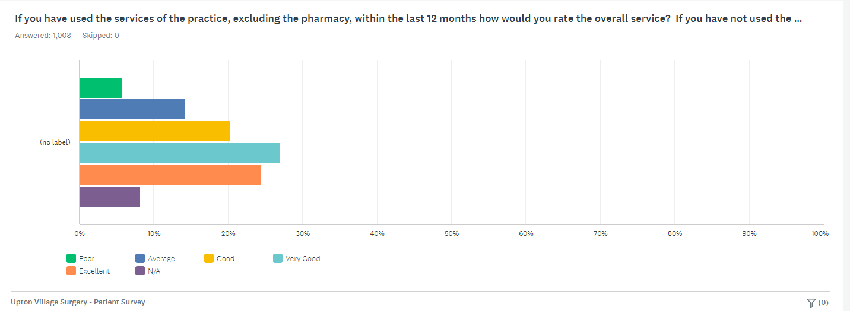
Question 4: Regardless of whether or not you have used the GP services recently, please choose the single most important change you would like to see at the GP practice.

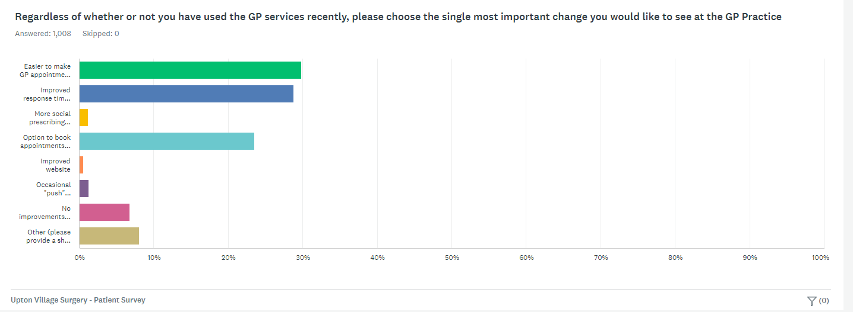

Options in descending order: Easier to make GP appointment, improved response time when making appointments by phone, more social prescribing activities (eg walking & singing groups), option to book appointments online in advance, improved website, occasional “push” notifications by text/email about new health & wellbeing information, no improvements required.

Question 5: If you have used the online facilities to contact the GP practice in the last 12 months, please rate your experience of using this service.

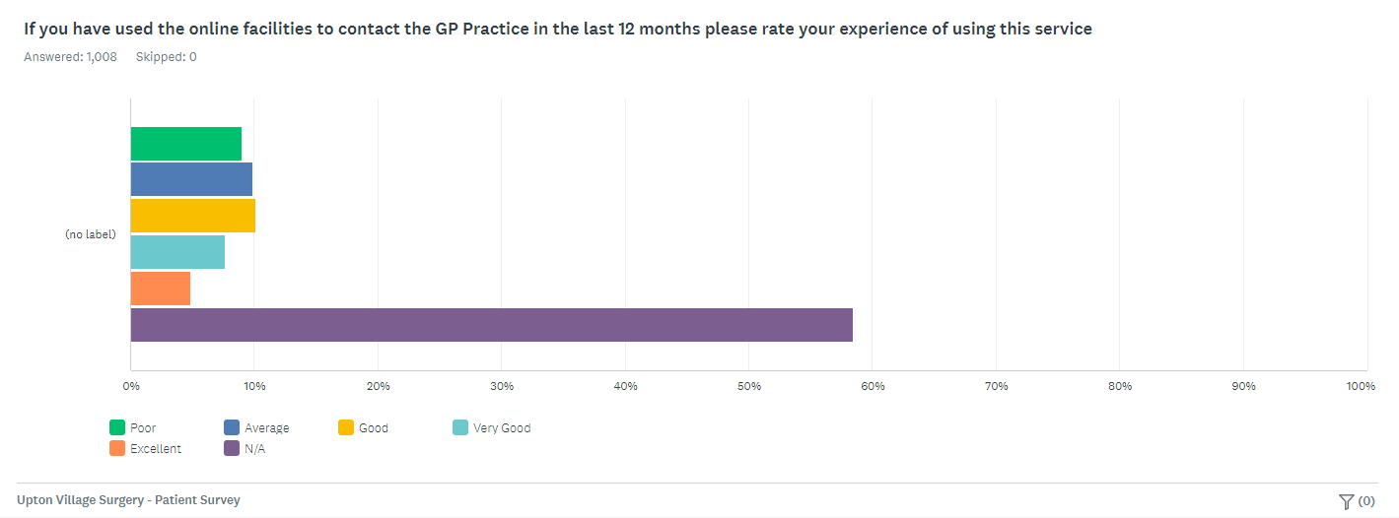
Question 6: If you have contacted the practice by phone in the last 12 months, how would you rate your experience?

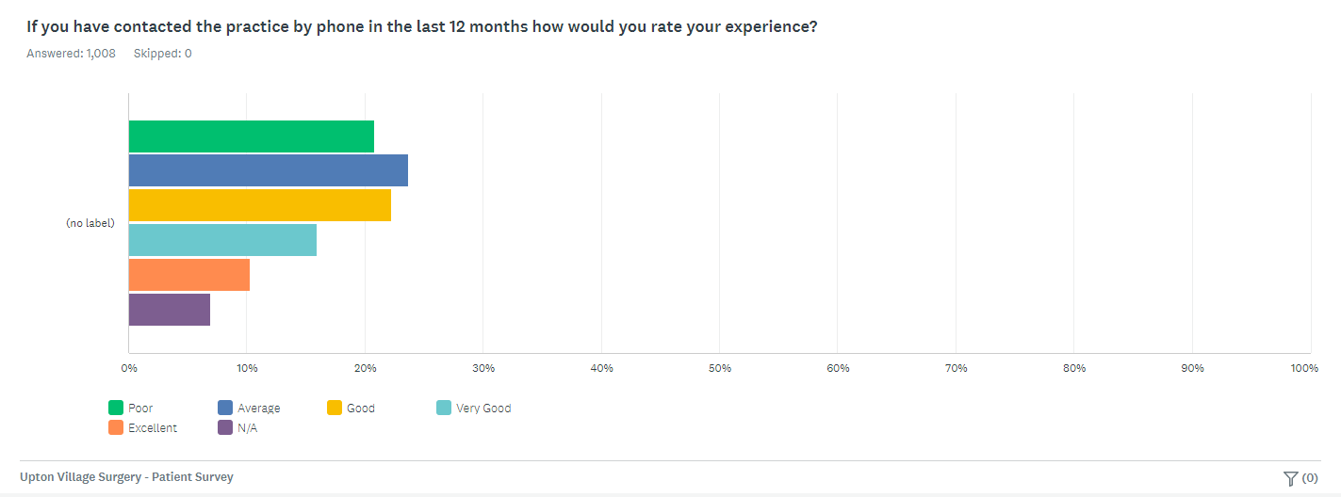
Question 7: Are you aware of recent changes that have resulted In the practice becoming part of a local Primary Care Network (PCN), which includes working together with three other local practices to make best use of recourses.

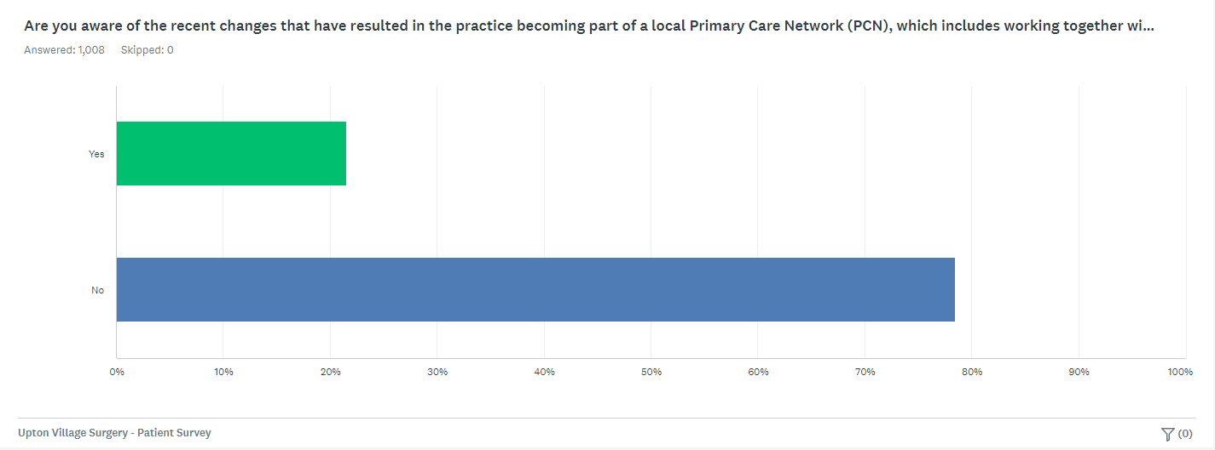

Question 8: Are you aware of the recent appointments of a Physiotherapist and a Mental Health Practitioner (both one day a week) as part of the PCN changes.

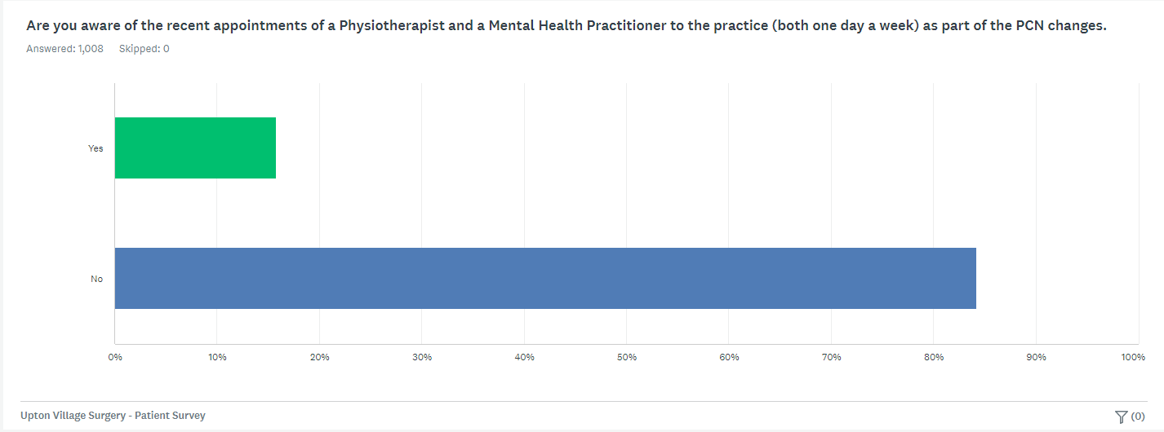
Question 9: Would you like to subscribe to the quarterly newsletter produced by the PPG on behalf of the practice? This includes general health and wellbeing information as well as news about the practice.

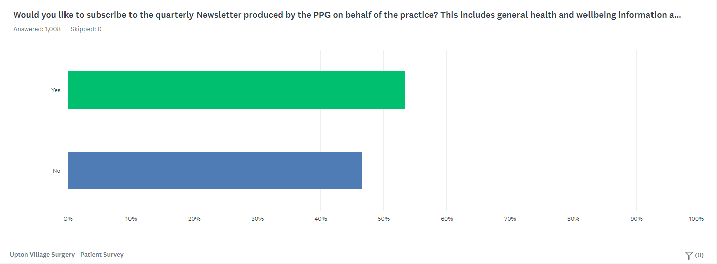
We did!
You said…
Your feedback

I have difficulty getting through at 8am in the morning on the phone (32)
The practice has recently heavily invested in an upgraded phone system. Our new system offers a call-back system which will greatly improve the patient experience when making an appointment at 8am.

We will shortly be getting a new system which will allow patients to submit e-Consults via our website. A response will then be provided by the practice within 48 hours. This system will allow our patients greater choice with how they choose to consult with the practice.

I would like the option to consult with the GP online (16)

Renovations are needed at the practice, particularly the waiting area toilet.
The practice is looking to make internal improvements and will be undergoing renovations. Patients will be kept updated on when this work will begin.

A mixture of telephone consultations and face to face appointments are available and are offered as deemed appropriate when your call is triaged by our Patient Services team. If the clinician feels they need to see you after speaking on the phone, a face to face appointment will be arranged.
I would like to request for face to face appointments and not telephone call (10)

Upton Village Surgery is part of a collaboration of practices alongside Heath Lane Medical Centre, Park Medical Centre and Boughton Medical Group that form the Chester East Primary Care Network. Further information can be found here on their Facebook and website:
https://www.facebook.com/profile.php?id=100087627288171
https://chestereastpcn.co.uk/
Further information can also be found on our practice newsletter here:
I am unaware that Upton Village Surgery is part of a Primary Care Network (PCN) (1)

